

**Submitted by: Submitted to:**

**NAME: Rahul Gusain Hitesh Kumar Sharma**   
 **SAP: 500084143**  
 **ROLL NO.: R214220900**  
 **BATCH: 1 DevOps**

EXPERIMENT 3

AIM: Working with Docker Volume

Steps to Complete:

1.View all Volume in Docker

**Command :** docker volume ls

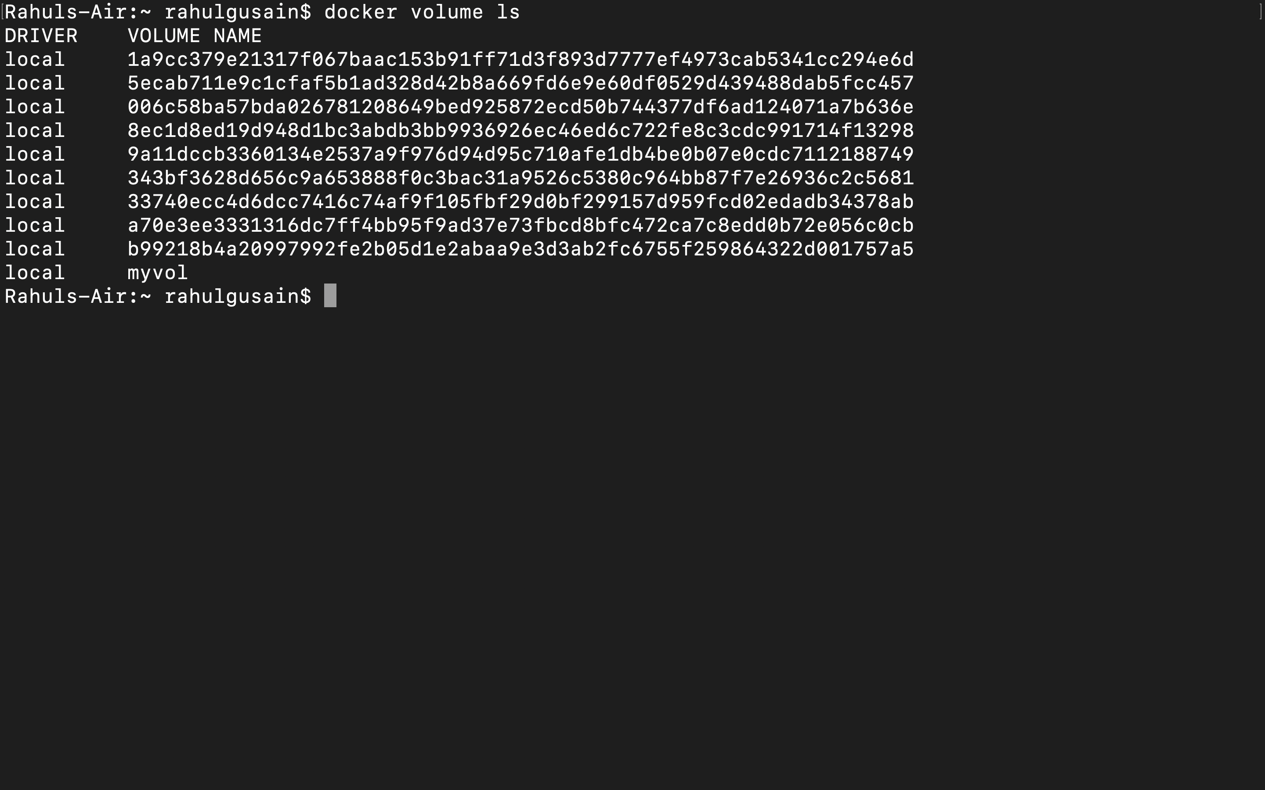

2.Create a new Volume

**Command:** docker volume create myvol2

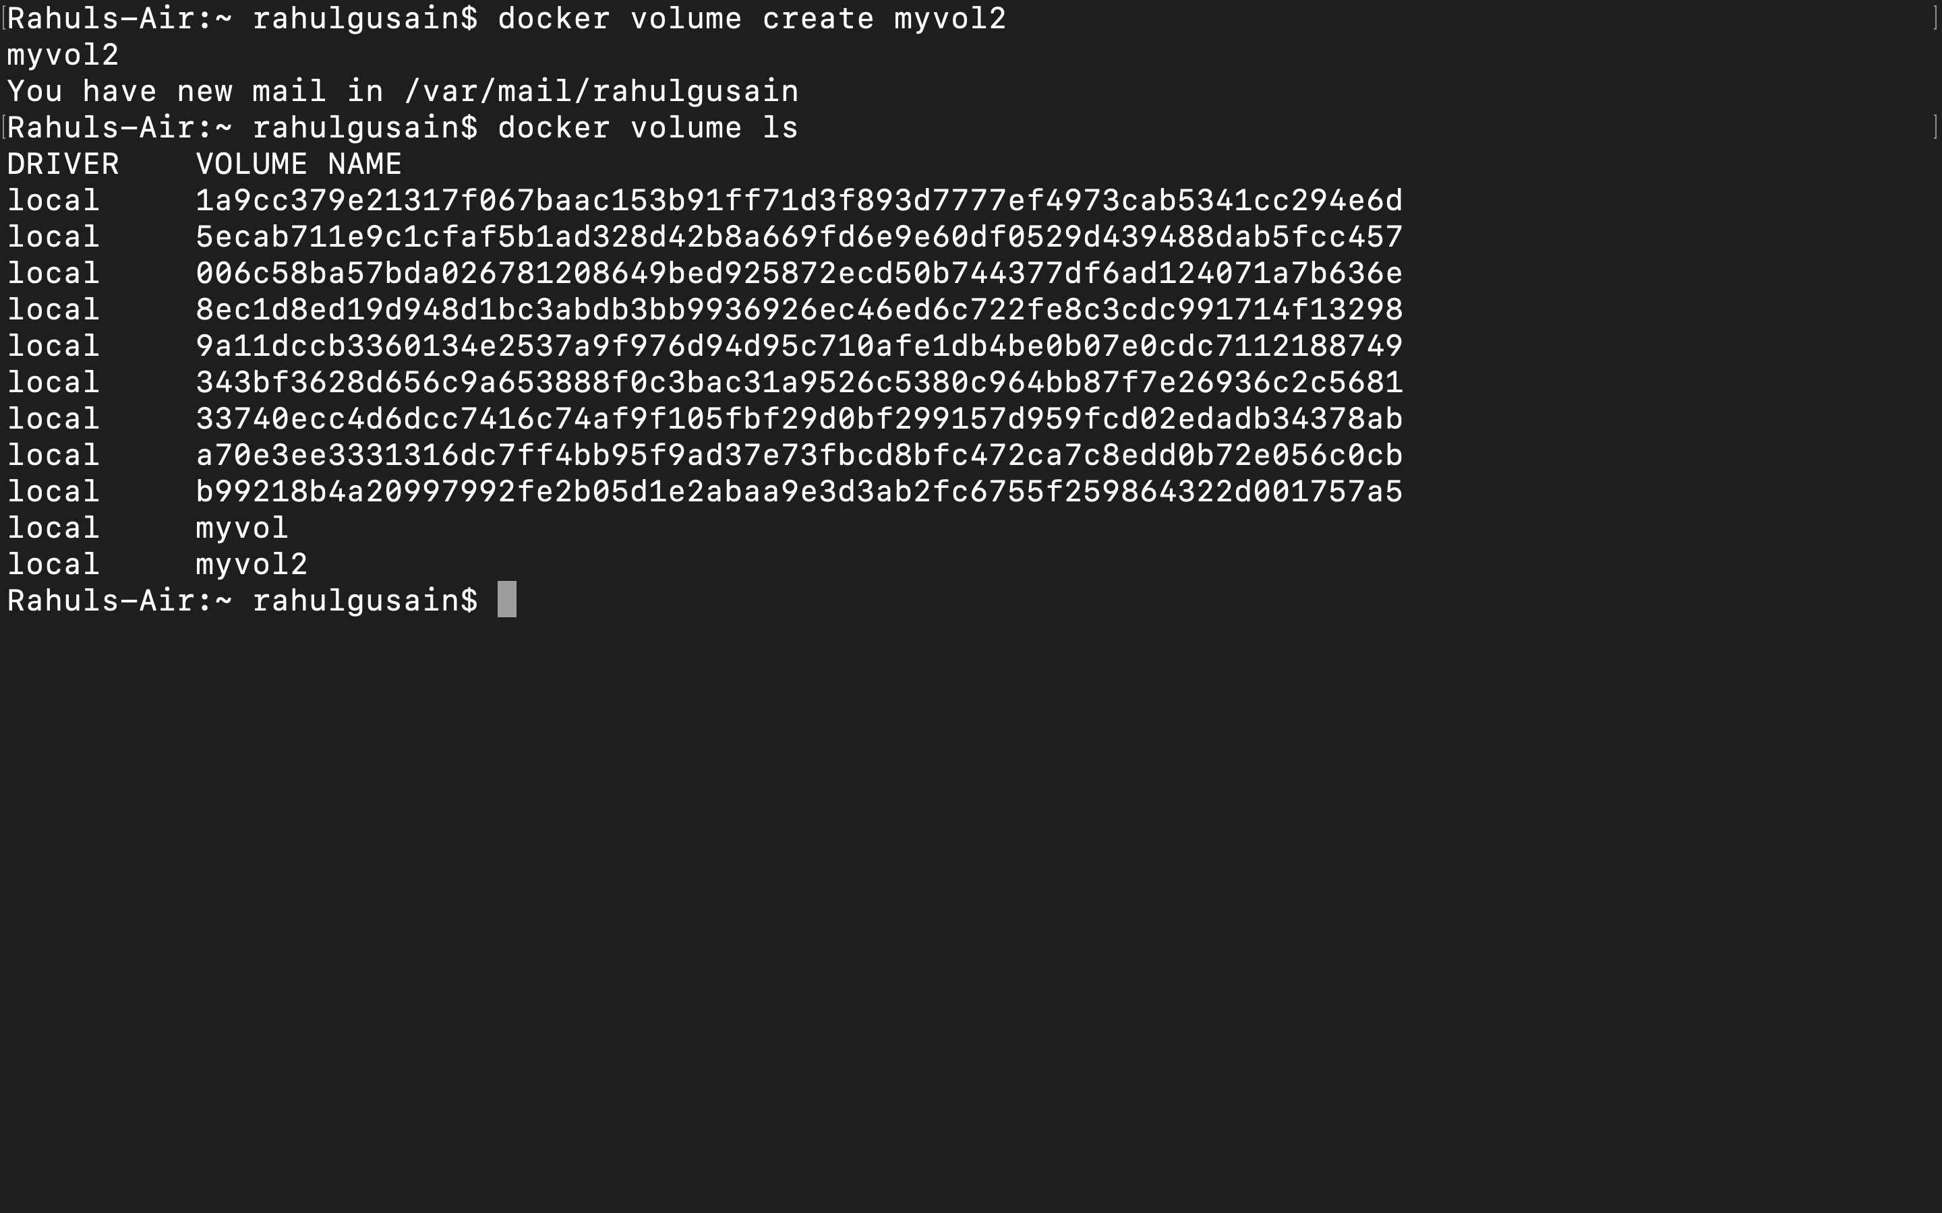

3.Mount a Volume with a container

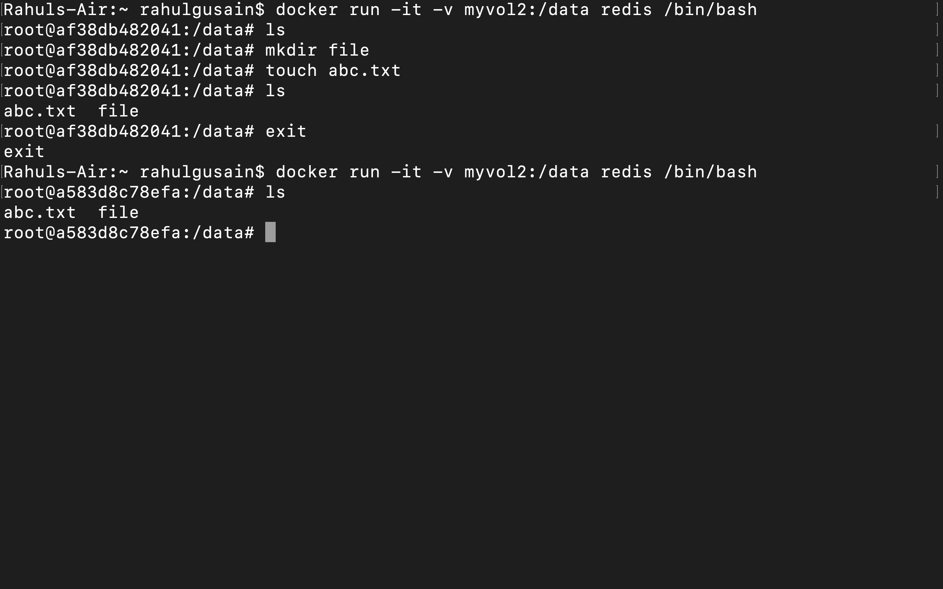

**Command:**  docker run –it –v myvol2:/data redis /bin/bash

4.Create another container and Mount with the same Volume

**Command:**  docker run –it –v myvol2:/data redis /bin/bash



5.See the complete working of container

**Command:**  ls

mkdir



6.Exited from container and restart again to see the persistent of Docker Volume

**Command:** docker start af38

docker attach af38  
 